**Lab_Day-1 (Introduction to Python)**

**Downloading the Python**

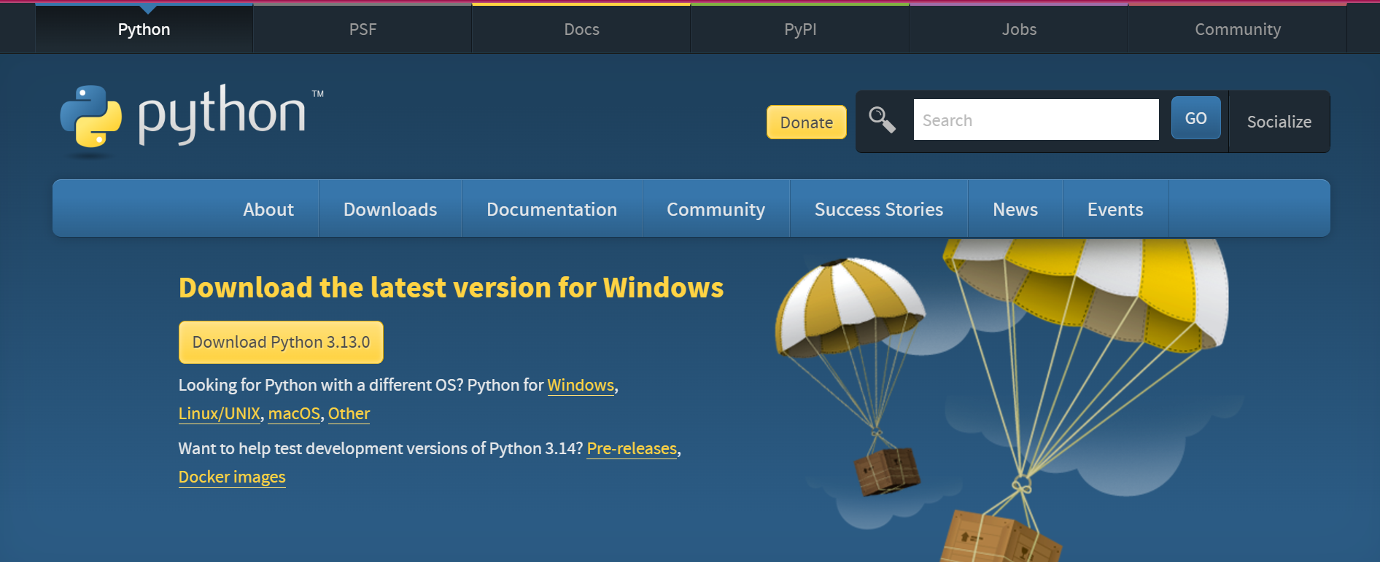

**Installing the Python**

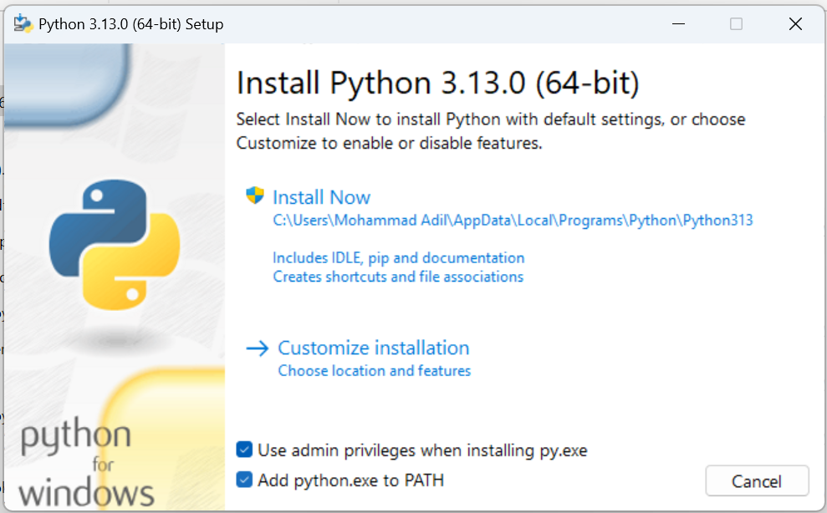

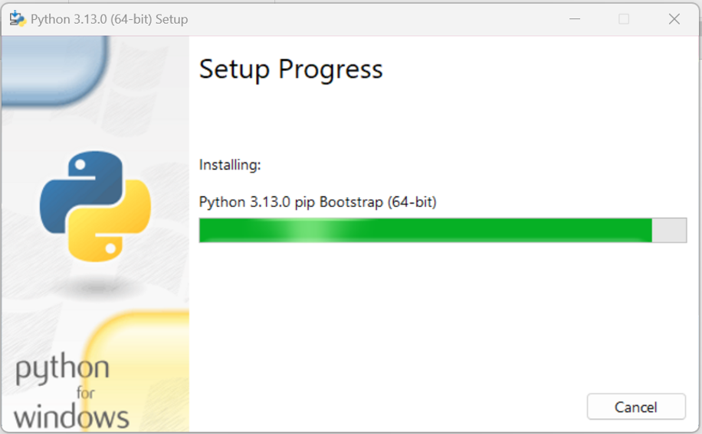

**Verifying**

